HRM (WIREFRAME)

- Main Admin
- Admin
- HR
- Employee
- Shared HR modules

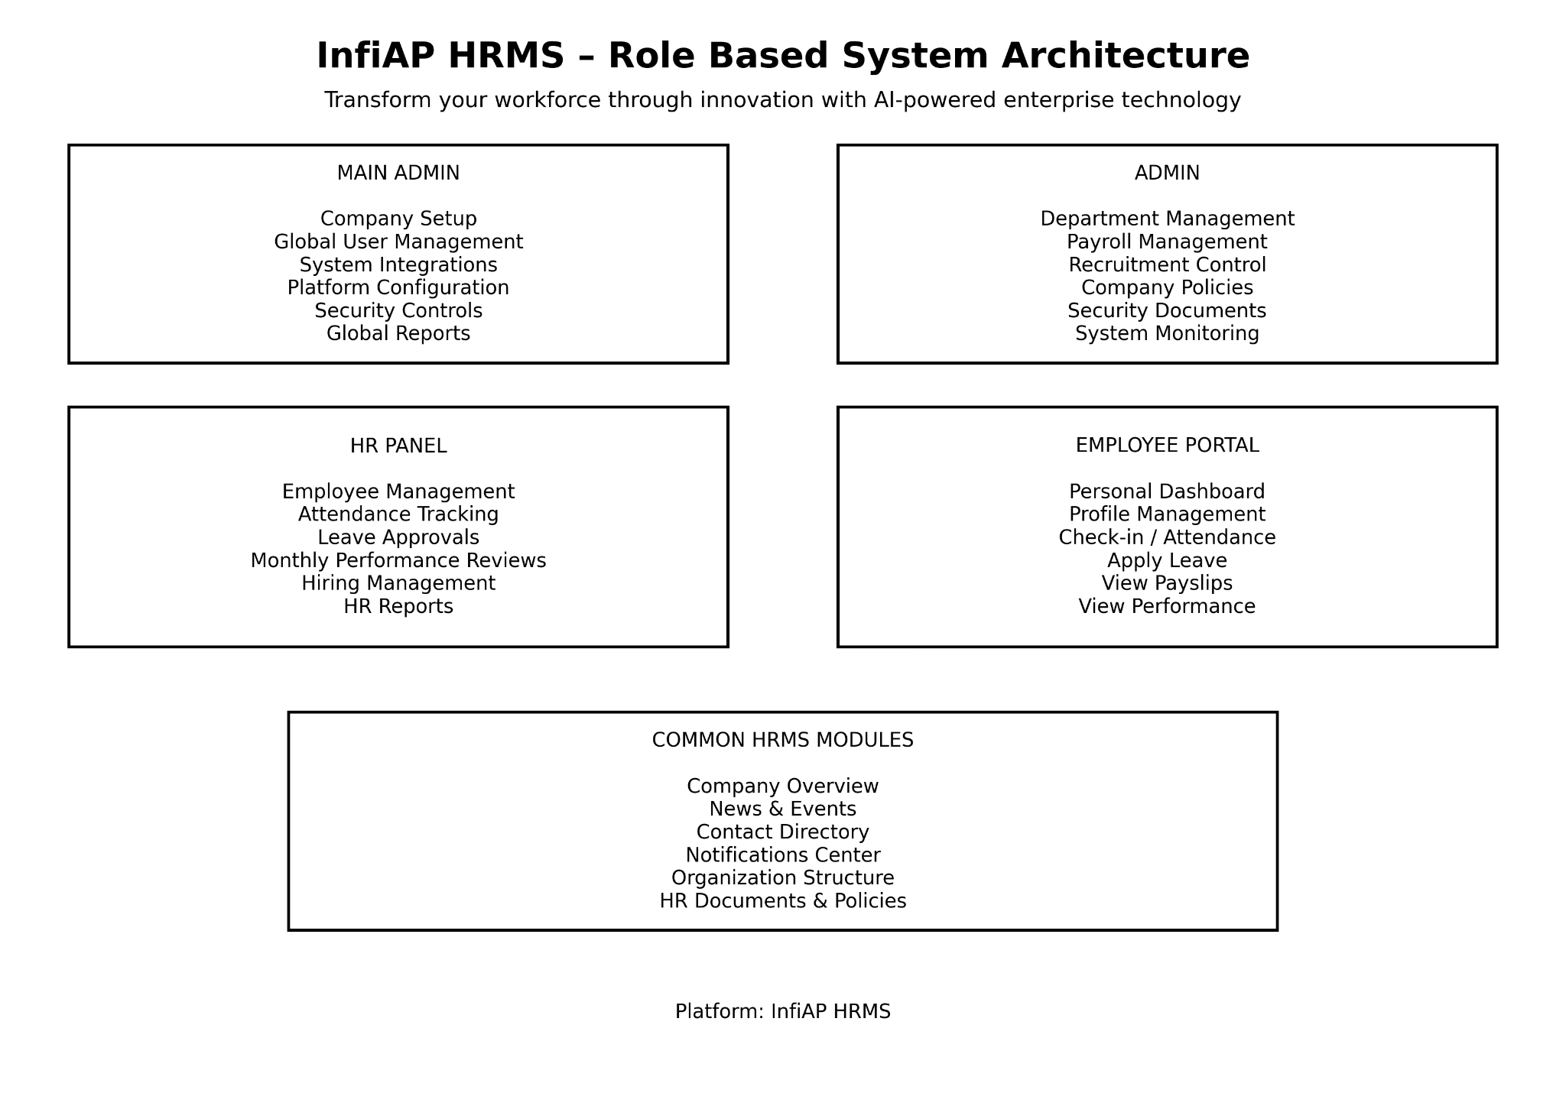

InfiAP HRMS – System Wireframe (Role Based Architecture)
INFIAP HRMS PLATFORM
Transform your workforce through innovation with AI-powered technology

1️⃣ Authentication Layer
Sign Up
│
Sign In
│
Forgot Password
│
User Role Detection

System identifies user role:
Employee
HR
Admin
Main Admin

2️⃣ Main Admin Panel (System Owner)
MAIN ADMIN DASHBOARD
│
├── Company Setup
│
├── Global User Management
│ ├ Add Admin
│ ├ Add HR
│ └ Manage Permissions
│
├── Platform Configuration
│
├── System Integrations
│ ├ Cloud Services
│ ├ Email System
│ └ Security Controls(if company need to change something they have to gen OTP then only then update something)
│
├── Global Reports & Analytics
│
└── System Monitoring

Purpose:
Controls the entire HRMS platform.

Your security flow now becomes professional like real SaaS systems:
Company Admin
│
Request Change
│
Generate OTP
│
Main Admin Receives OTP
│
Verify OTP
│
Approve / Reject Change
│
System Updates Settings

3️⃣ Admin Panel (Company Level Admin)
ADMIN DASHBOARD
│
├── Department Management
│ ├ Create Department
│ └ Manage Teams
│
├── Payroll Management
│ ├ Salary Structure
│ ├ Payslip Generation
│ └ Finance Reports
│
├── Recruitment Control
│ ├ Job Posting
│ ├ Candidate Tracking
│ └ Interview Management
│
├── Company Policies
│
├── Security Documents
│
└── System Settings

Purpose:
Manages organizational operations.

4️⃣ HR Panel
HR DASHBOARD
│
├── Employee Management
│ ├ Add Employee
│ ├ Edit Employee
│ └ Employee Profiles
│
├── Attendance Management
│ ├ Check-in Records
│ ├ Monthly Attendance
│ └ Attendance Reports
│
├── Leave Management
│ ├ Leave Requests
│ ├ Leave Approval
│ └ Leave History
│
├── Recruitment
│ ├ Candidates
│ ├ Hiring Applications
│ └ Interview Scheduling
│
├── Employee Performance
│ ├ Monthly Performance
│ ├ Manager Feedback
│ └ Performance Reports
│
├── Finance Department
│ ├ Payroll Overview
│ ├ Salary Processing
│ └ Payslip Management
│
├── Resignation Management
│ ├ Submit Resignation
│ ├ Resignation Requests
│ └ Exit Process
│
└── HR Analytics
├ Employee Reports
├ Attendance Analytics
└ Performance Insights

Purpose:
Handles daily HR operations.

5️⃣ Employee Self-Service Portal
EMPLOYEE DASHBOARD
│
├── Personal Profile
│ ├ View Profile
│ └ Update Profile
│
├── Attendance
│ ├ Check In / Check Out
│ └ Attendance History
│
├── Work Schedule
│ ├ Schedule Settings
│ ├ Work Timing
│ └ Shift Details
│
├── Leave Management
│ ├ Apply Leave
│ └ Leave Status
│
├── Payroll
│ ├ Payslips
│ └ Salary History
│
├── Performance
│ ├ Monthly Score
│ └ Manager Feedback
│
├── Notifications
│ ├ HR Announcements
│ ├ Admin Notifications
│ └ System Alerts
│
└── Activity Log
├ Attendance Updates
├ Leave Updates
└ Payroll Updates

Purpose:
Allows employees to manage their own information.

6️⃣ Shared HRMS Modules
Accessible across roles.
COMMON PLATFORM FEATURES
│
├── Company Overview
│
├── News & Events
│
├── Internal Contact Directory
│
├── Organization Structure
│
├── HR Documents
│
├── Notifications Center
│
└── Activity Logs

7️⃣ HRMS Core Data System
DATABASE
│
├── Employee Database
├── Payroll Data
├── Attendance Records
├── Recruitment Data
├── Performance Metrics
└── Company Documents

layout:
HRMS PLATFORM
│
┌────────────┼────────────┐
│ │ │
Main Admin Admin HR
│ │ │
└────────────┼────────────┘
│
Employee
│
Shared Modules
│
Database

